08/13/20

Dear Brothers, Sisters, Partners and Friends,

In this season of pandemic, civil unrest and disorder, I find peace in these words that God spoke to encourage and comfort Israel: “For I, the Lord your God, hold your right hand; it is I who say to you, ‘Fear not, I am the one who helps you.’” Isaiah 41:13 (ESV). I am grateful to God for granting to you and me the same kind of faith that allowed Paul to pray for the Roman believers, and so allows me to express that same prayer for all of you: “I pray that God, the source of hope, will fill you completely with joy and peace because you trust in him. Then you will overflow with confident hope through the power of the Holy Spirit.” Romans 15:13 (NLT).

It is in such drastic times as these that we are reminded of the importance of the mission that Jesus has equipped and commissioned us to: “But you will receive power when the Holy Spirit comes upon you. And you will be my witnesses, telling people about me everywhere—in Jerusalem, throughout Judea, in Samaria, and to the ends of the earth.” Acts 1:8 (NLT). “Therefore, go and make disciples of all the nations, baptizing them in the name of the Father and the Son and the Holy Spirit. Teach these new disciples to obey all the commands I have given you. And be sure of this: I am with you always, even to the end of the age.” Matthew 28:19–20 (NLT). “Sin will be rampant everywhere, and the love of many will grow cold. But the one who endures to the end will be saved. And the Good News about the Kingdom will be preached throughout the whole world, so that all nations will hear it; and then the end will come. Matthew 24:12–14 (NLT).

I am writing to pray for and encourage you to stay steadfast and on mission with the Lord as he faithfully directs you. Also, to update you, since it was November, 2019 when I last wrote to you all.

Daisy and I moved to Bradenton Fl. this past December and share an apartment with our daughter Tess and son in law Vito. You may recall that Daisy broke her shoulder last October just days before I left for Africa. Since having surgery in Maine, she has been in physical therapy down here and hopes to be done within a month or so. I work as a security officer at the same hospital that my daughter Tess works at and where Daisy has therapy. I work 3 twelve hour days and have 4 off which allows me ample time for ministry.

Though due to the pandemic, I will not be travelling to the African Mission Field this fall, we are still fully on task and devoted as ever to partnering with and ministering to the disciple making movement leaders, disciples and church throughout the U.S., the Horn of Africa and beyond. The funds budgeted for the 2020 trip were sent instead as financial aid to the suffering disciples throughout Ethiopia and in Nairobi Kenya, the bulk of it to Ethiopia (see below a report from our partners, Emmanuel United Church of Ethiopia):

**RELIEF DONATION REPORT AND FINANCIAL BREAKDOWN**

1. **Activities:**

We really thank God for the partnership He has given us with our dear brother Pastor Paul Parker. We have got a donation of 5,000USD for our urgent relief project work to help our churches and communities who are affected by the impact of Corona Virus (Covid-19) and Locust invasion. Our government has declared a state of emergency and many people here in Ethiopia are in life and death situation and literally struggling to put food on their tables due to Covid–19 restrictions.

However, God has used Pastor Paul and his wife Daisy Parker and all his partners to intervene in this situation and I take this opportunity to thank Pastor Paul and his ministry team who have been working tirelessly to raise funds for us and have helped us to help those who are in need.

According to our relief project plan our target churches and communities were in two regions that are Eastern Wollega and Bosset district (Nazareth/Adama/ & Welenchity area). But, we have included the southern region in this donation. Because we felt that this region is also affected by locus invasion.

We have used our regional office and regional coordinators to distribute the food to the needy areas. In Some regions like Western Wollega and Southern regions we have sent the money to our regional office account to execute it. The reason why we did that is because we can not travel to those places due to the travel restrictions and the current unrest and violence particularly in Western Wollega region. But, we have got report from our regional coordinators how they executed it.

In some places like Adama/Nazareth/ area and its surrounding villages; we offered goats for orphans so that it will help them to get milk and reproduce more goats. This support has two-fold strategy which is addressing the immediate needs for relief for the child while ensuring the long-term, independent sustainability of care.

Here in the table below we have put some information about the regions and the budget briefly.

1. **Table: - Regions & budget allocations**

|  |  |  |  |  |  |
| --- | --- | --- | --- | --- | --- |
| **No.** | **Name of the Region & Communities** | **No. of beneficiaries** | **$ for 1 household** | **Food provided** | **Total Amount**  **$USD** |
| 1. | Central Region/Nazareth & Welenchity Area | 85 | 21USD | - 15Kg of wheat flour  - 2liter of food oil  - 1 set of Pasta /Spaghetti/  -1set of Macaroni  - 1kg of sugar | 1,785 |
| 2. | Southern Region/Wolayita & Arbaminch area/ | 57 | 21USD | “     “ | 1,197 |
| 3. | Eastern Ethiopia Region/Kelem Wollega Area/ | 62 | 21USD | “     “ | 1,302 |
| 4. | Communication & Transportation |  |  |  | 400 |
| 5 | Goats | 5 | 50USD |  | 250 |
| **5.** | **TOTAL** |  |  |  | **4,907** |
| 6. | BUDGET SENT FROM Daisy |  |  |  | 5,000 |
| **7.** | **BALANCE** |  |  |  | **93** |

1. **Some stories and photos**

* One of Evangelists in Western Wollega region whom I can not mention his name for the purpose of confidentiality has four children; three girls and one boy. The last born is 3 years’ old. He and his family did not have food for two days. As His children were starving and suffering our food got arrived in his village. And he was so exited and thanked God for His provision. I call this food ‘Miracle food like Manna’ he said in tears after he received the food donation.
* An eight-year-old Gelane lives in one of the villages in Boffa area with her aunty. She lost her parents due to HIV Aids and her aunty is taking care of Gelane with her other 3 kids. Gelane has received goat and she was so exited. Goats are very important animal in her village. She said that she is expecting more goats in a few years and she is looking after it in her villages with other goats. And she is also planning to give goats to other orphans when her goat reproduces more goats. We thank God for this project. So far, so many children have been transforming through this little gift.

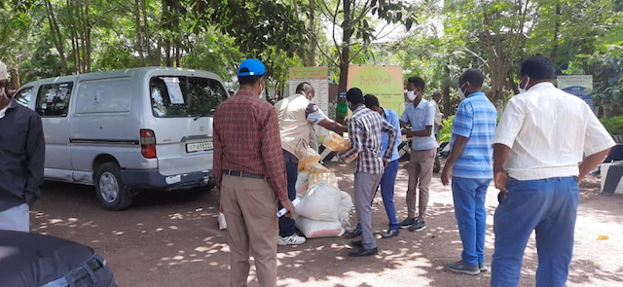 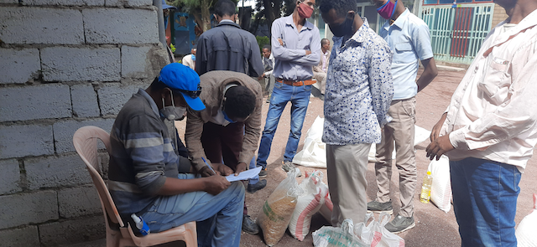  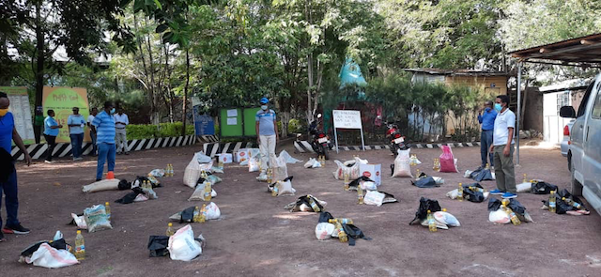

*Preparing and Setting up the Food donation in Adama/Nazareth/ ( 1st round)*

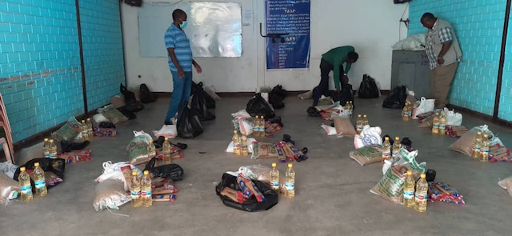 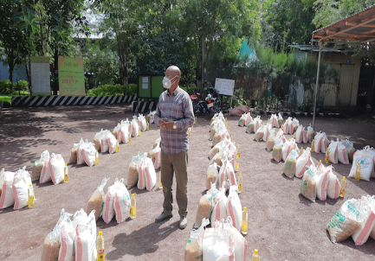 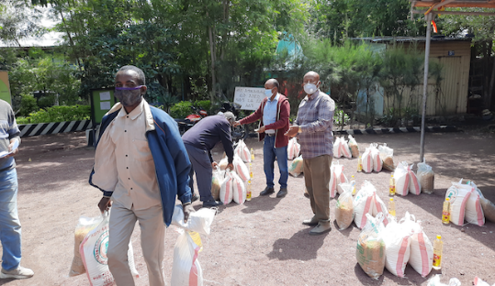

*Food donation handing – out in Adama / Nazareth/ for people who have come from the surrounding villages of Adama /Nazareth/ Town.*

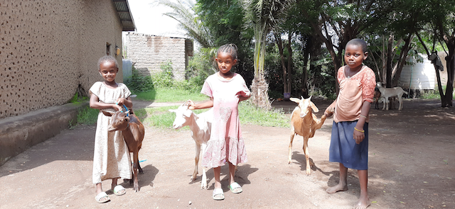 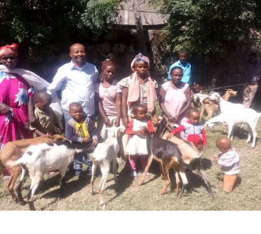

*Goats support for some of the Orphans in Boffa Village a*

We continue to develop a website that will focus mostly on providing reproducible training materials in English, Swahili and Amharic languages. Our website also offers links to several resources which will help equip disciples and their leaders. I am currently preparing to write an extensive biblical exposition/dissertation on the Kingdom of God and the Good News thereof. Once completed, I will break it down into several teaching modules that should serve to keep the ever-growing disciple making movement in Africa stay on track with the movement Jesus started and is continuing through them and help them steer clear of the pitfalls of a “Cultural Christianity” which threatens their movement daily. God willing, I will return to Africa in the fall of 2021 with these and other trainings.

Please join me in praising God for His continued direction and provision for The Master’s Mission International. Thank you for your continued prayer and/or financial support of and partnership with “The Master’s Mission International.” As you know, without the support of people like yourself, such work would not be possible.

It’s always a great encouragement to hear from you who are partnering with me in prayer. Also, if you desire to give your financial support, there is a donate button on our web page or checks may be sent and made payable to The Master’s Mission International, 11120 Lost Creek Terrace, Apt. 209, Bradenton, FL 34211.

I thank God and pray His constant blessing upon you all for your faithful and continued partnership, support and encouragement in ministry.

Please don’t forget to visit and follow us at our newly formed web site and/or Facebook page: [www.themastersmissioninternational.org](http://www.themastersmissioninternational.org) and bookmark it a.s.a.p. Be sure to sign up to continue receiving newsletters in the future! Please feel free to share our web address [www.themastersmissioninternational.org](http://www.themastersmissioninternational.org) with anyone you think may be interested.

Sincerely Yours,

Rev. Paul L. Parker

A.K.A. Pastor “Chico”

Org: The Master’s Mission International

Email: [pastorchicop@gmail.com](mailto:pastorchicop@gmail.com)

Web: [www.themastersmissioninternational.org](http://www.themastersmissioninternational.org)

Ph.: 1-207-592-5911