07-24-21

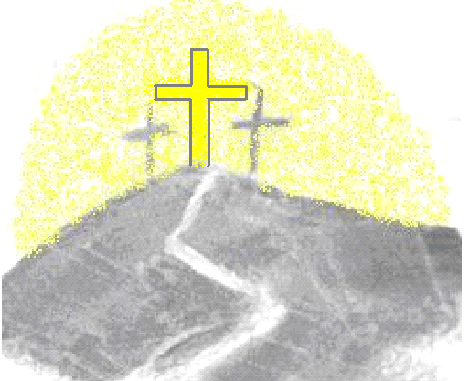The Masters Mission International

Developers of International Disciple-making Movement Leaders

50 Lone Pine Road, North Waterboro Maine 04061

Dear Brothers, Sisters, Partners and Friends,

I thank the Lord as always for your friendship, partnership and support. This is the second letter in regards to the upcoming November-December 2021 ministry trip to Ethiopia. There are pertinent details and important information contained in the previous 05-14-21 newsletter that I am requesting you to briefly review by selecting **ctrl** and then clicking on this link: <https://www.themastersmissioninternational.org/current-newsletter>

I would like to remind my long time supporting partners as well as inform new and potential ministry partners of who The Master’s Mission International (T.M.M.I.) is and what we have been commissioned by the Lord to do.

It has been over 100 years since modern missionary efforts began in Ethiopia but up until about 13 years ago, very few “Muslims” there had received Jesus. Around 2008 we began to recognize a tremendous movement in Ethiopia and other countries in Africa, of ‘Muslims’ coming to a saving relationship with Jesus. In 2010 I was led by the Lord to make my first trip to Ethiopia in order to help recognize, equip and release much needed disciple making movement leaders into the harvest God was providing. The church in Ethiopia and disciple making movements throughout the Horn of Africa continue to multiply rapidly and is in desperate need of more and more leaders to be developed, equipped and released. I am humbled, excited and blessed to have been participating since 2010 in this opportunity to help in God’s equipping ministry. Each year I receive more requests to come and minister to developing leaders and movements throughout Africa. This is an answer to your and my prayers. Because we follow the Master’s plan of leadership development and multiplication, this growth is easily sustainable. Each newly trained leader is committed to multiplying leaders who will multiply more disciple making leaders! In this way a small financial donation is truly a gift that keeps on giving! To see more of what the Lord has been doing through T.M.M.I. over the past 11 years see all the archived newsletters at <https://www.themastersmissioninternational.org/archived-letters>.

T.M.M.I. is a non-profit ministry who meets the minimum requirement of 3 board members none of which receive any proceeds from T.M.M.I. what so ever. We are 100% funded by donating partners such as yourself. Pastor “Chico” provides for all his own traveling expenses. All donations are used to sponsor students travel, food and lodging costs. These indigenous church leaders could not participate without these donations. Though we remain good stewards of the Lords finances, our budget increases each year. I am glad to report that this is largely due to the expanding number of people we are reaching and the new regions that are becoming ripe unto harvest.

On our 1 week inaugural training in 2010 we trained 17 Key regional leaders at 1 location and had a $2,500 budget. In 2019 we served for 2 weeks in 2 locations, Addis Ababa and Nazareth/Adama, in all about 75 leaders were trained and encouraged. In 2020 the pandemic prohibited us from traveling to Africa, instead we sent $5,000 USD in crisis relief funds. Through all the heartache the church in Ethiopia grows vibrantly and is in need of much leadership training and support. In 2021 from November 13th through December 5th I am committed to train and encourage 200 leaders over 5 different locations, 4 of which are new regions of development. This, because of the Holy Spirit’s blessing and the efforts of previously trained leaders to make disciples, plant churches and pass on the training they have received and exponentially multiply the Disciple Making Movement in Ethiopia. To learn more about T.M.M.I. go to <https://www.themastersmissioninternational.org/about> and to <https://www.themastersmissioninternational.org/mission-values>.

As our efforts to serve in 2021 have tripled, so has our budget. In 2019, through your generosity and by His grace, God met our financial needs of $6,000 USD. So, in 2021 we continue to trust that our God who continues to redeem and transform lives in Ethiopia will provide the needed $16,000 for us to serve and support them.

Please continue to pray for the following:

* The Lord’s financial provision of approximately $16,000.00 to cover all expenses.
* The Lord’s guidance and blessing in our 2021 missionary efforts to Africa.
* The Lord multiply radical life transformation through our partnerships.

Thank you for your continued prayer and/or financial support of and partnership in Africa Missions. As you know, without the support of people like yourself, such work would not be possible. Just 65 USD will provide transportation, meals and housing to enable a church leader to receive sound biblical training that will enhance their efforts in implementing powerful Christ-like disciple making movements in their respective regions in Ethiopia and beyond. When you financially and prayerfully support this ministry, you make an eternal investment in the Kingdom of God.

It’s always a great encouragement to hear from you who are partnering with me in prayer. Also, if you desire to give your financial support, there is a donate button on our web page, or checks may be sent and made payable to The Master’s Mission International, 11120 Lost Creek Terrace, Apt. 209, Bradenton, FL 34211.

Please don’t forget to visit and follow us at [www.themastersmissioninternational.org](http://www.themastersmissioninternational.org) and bookmark it a.s.a.p. Be sure to sign up to continue receiving newsletters in the future!

Please feel free to share our web address [www.themastersmissioninternational.org](http://www.themastersmissioninternational.org) and/or a copy of this newsletter with anyone you think may want to partner with us.

I thank God and pray His constant blessing upon you all for your faithful and continued partnership, support and encouragement in ministry.

Sincerely Yours,

Rev. Paul L. Parker

A.K.A. Pastor “Chico”

Org: The Master’s Mission International

Email: [pastorchicop@gmail.com](mailto:pastorchicop@gmail.com)

Web: [www.themastersmissioninternational.org](http://www.themastersmissioninternational.org)

Ph.: 1-207-592-5911